Practical – 2

Semantic HTML5 Pages with Accessibility-Ready Structure
Problem Definition : Develop static HTML5 skeletons for at least 10 StudentHub pages such as Home, About, Register, Login, Dashboard, Events, Profile, Contact, Admin, FAQ, and Feedback. Use semantic tags and accessibility-friendly structure.

A. THEORY
1. Are semantic tags such as header, nav, main, section, article, aside, and footer used properly?
Yes. Semantic HTML5 tags are used properly to organize the webpage structure. They make the content clear and easy to understand.
2. Are form labels, headings, image alt text, and navigation links accessible?
Yes. Proper labels are provided for form fields, headings are used in the correct order, alt text is added to images, and navigation links are clearly defined.
3. Is the page structure consistent across all pages?
Yes. All pages follow a consistent structure with similar header, navigation, main content, and footer sections. This makes the website easy to use and understand.
References
- MDN Web Docs – Semantic HTML
- MDN Web Docs – HTML Accessibility
- W3C – Web Accessibility Initiative
- MDN Web Docs – HTML `<img>` element

B. Implementation/ Output/Result
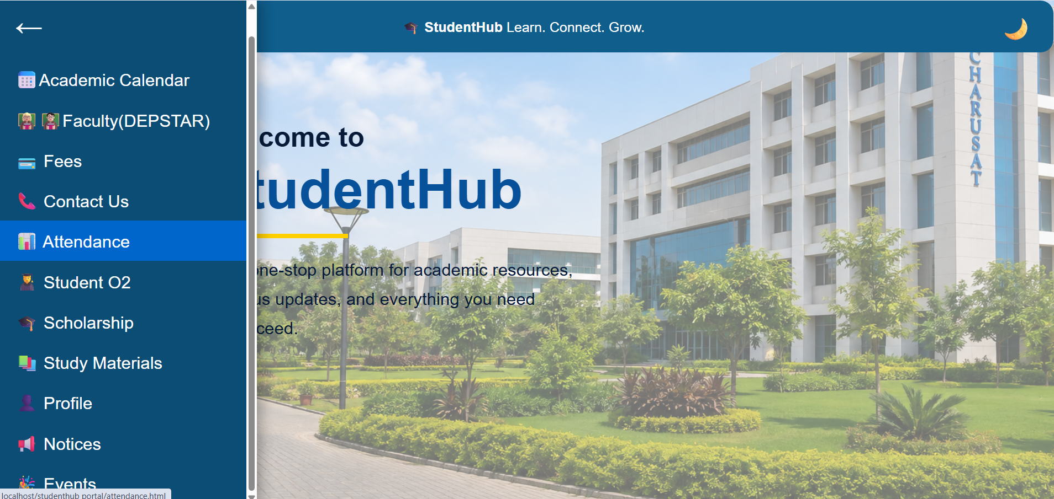

C. Evidence of Work (Screenshots)
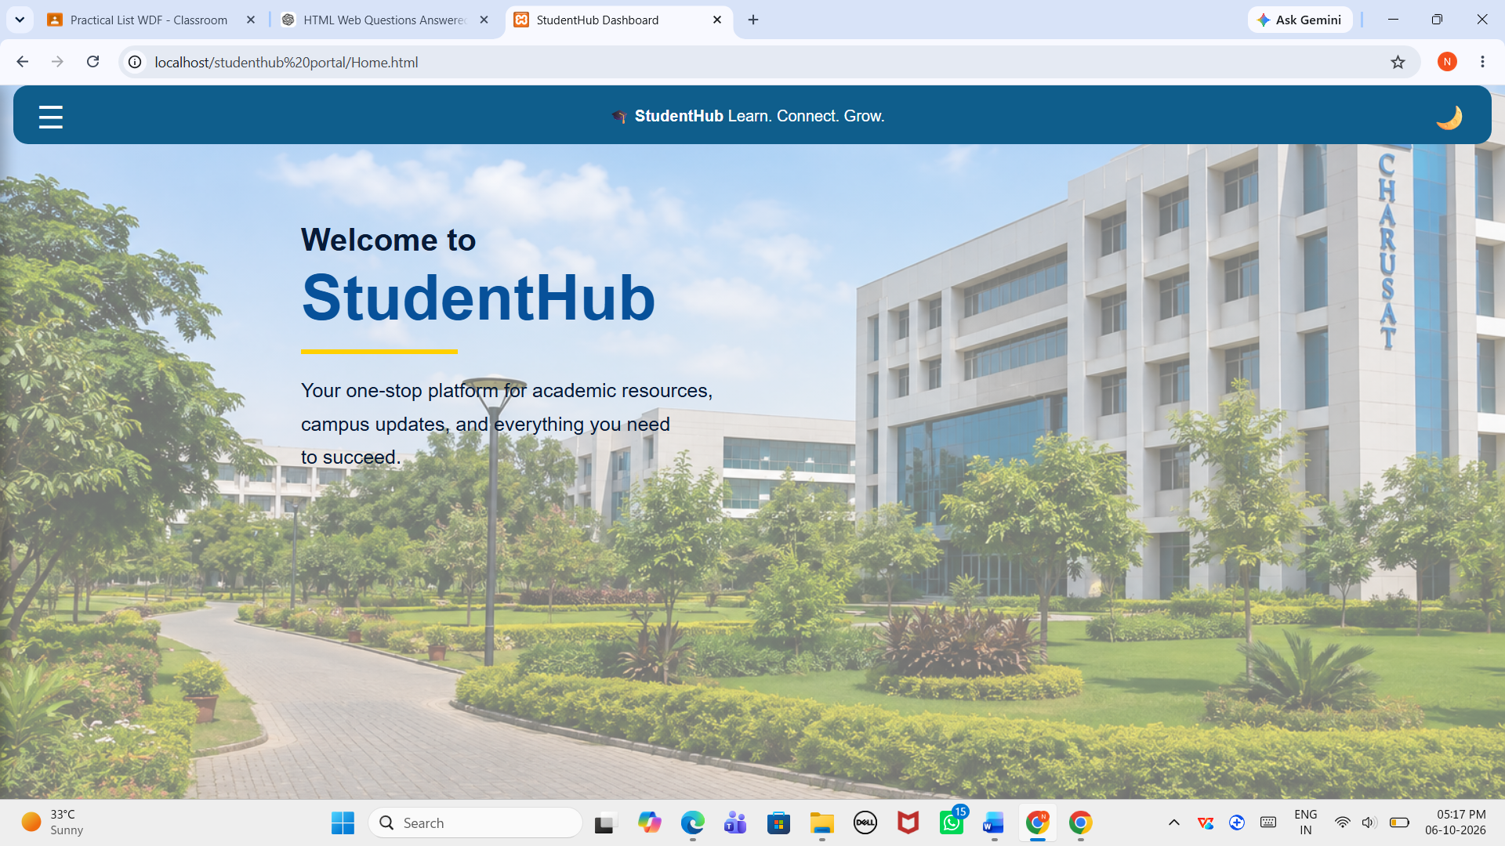
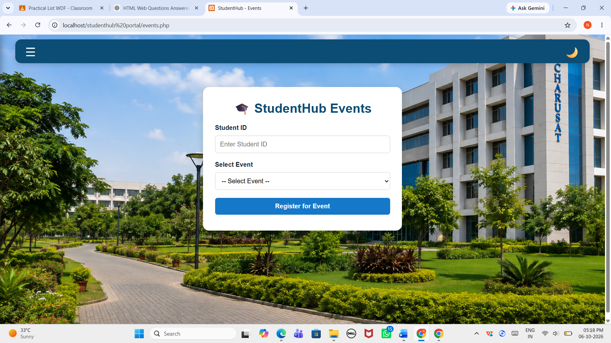

D. GitHub Repository Link
https://github.com/NencyNVagadiya/Student-Hub-portal/commit/1e87822bc7fe8a12b85d02fccb71971b902f2e1f

E. Challenges Faced:
“I faced difficulty in choosing the correct semantic HTML5 tags and creating an accessibility-friendly structure consistently across all the pages.”
F. Learning Outcomes:
Students will create clean, linked, and accessibility-ready HTML page structures.

G. Faculty Remarks:

